Chapter 8 Discussion with Answers

- Some designers suggest that speech recognition should be used in a telephone menu system. This would allow users to interact with the system by speaking instead of pressing buttons on the dial pad. Give two arguments for and three arguments against the proposal.

Arguments for include universal usability and limited vocabulary required to operate a phone

Arguments against include: error rates given current technology, stress conditions (e.g. calling for help in an emergency vs. calling a friend) can vary your speech, background noise influences

- A company is designing a kiosk that can display weather information in public locations. The kiosk will feature a touch screen so users can select a city by pointing on a map. Give three reasons why a touch screen is an effective device for this application.

No external pointing device (e.g. mouse) required, true human-computer interface is only the computer screen, with the computer, power supply, etc. hidden and protected in the kiosk container, intuitive interface design requiring no training.

- Explain the difference between direct-control and indirect-control pointing devices. Name a task when the one type is a more appropriate device than the other.

Direct-control example is our finger in a direct manipulation application, such as the kiosk in Question #2 above. The stylus on your PDA is another direct-control device. Indirect-control is a mouse connected to your workstation. The mouse increases precision in pointing tasks, it is low cost and widely available.

- Provide an example when speech generation would serve the user's need better than a visual screen. However, also provide a list of limitations the user would have by using the speech generator.

Speech generation and recognition may improve universal usability for those with physical challenges. Every designer must cope with the three obstacles to speech output: the slow pace of speech output when compared to visual displays, the ephemeral nature of speech, and the difficulty in scanning/searching. See Box 8.2 below:

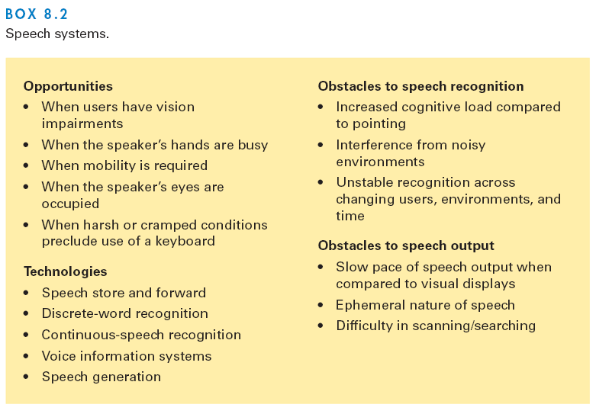

- The use of mobile devices has been increasing rapidly over the past few years. These devices typically feature much smaller screens than desktop computers. List two strategies of how you could successfully implement an interface to browse through a user's set of digital photographs on a small device.

Reading on small screens might also be improved with rapid serial visual presentation (RSVP), which presents text dynamically at a constant speed or at a speed adapted to the content.

Direct data migration into long, scrollable displays might be acceptable for linear reading but makes comparisons within the document difficult. Data modification involves summarizing text or creating smaller pictures. It is effective to provide quick access to all parts of the documents and allow users to request more information. Data suppression can be done by eliminating sections of the document, or selectively sampling words. Finally, compact overviews using visualization techniques (Chapter 14) can provide access to all of the original information.

- Give a definition of context-aware computing. Provide an example of one application of context-aware computing that would meet the user needs of a tourist.

Context-aware computing: mobile devices can use location information from Global Positioning System (GPS) satellites, cell-phone sources, wireless connections, or other sensors. Such information allows users to receive
information about nearby restaurants or gas stations, enables museum visitors or tourists to access detailed information about their surroundings, or helps users of tablet computers to connect to a printer located in the same room. The provocative applications of context-aware computing may open large markets, although concerns about privacy must be addressed.

